Harald Nordgren
Färögatan 6
164 40, Kista
0703-168908
ada09hno@student.lu.se

“Guided Transcoding for Next-Generation Video Coding (HEVC)” – Goal Document

Background and Context
Video compression is needed in order to transfer high-quality video with the current limitations of modern-day technology. An uncompress (RAW) 2 hour movie in HD quality could not be transferred over the internet in reasonable time, so for streamed video like Netflix or Youtube to work effectively, compression is needed in order to bring down the size several orders of magnitude without jeopardizing image quality. Images and video is an area which I have always been very curious about, so this thesis is a perfect oppurtunity for me to learn more.
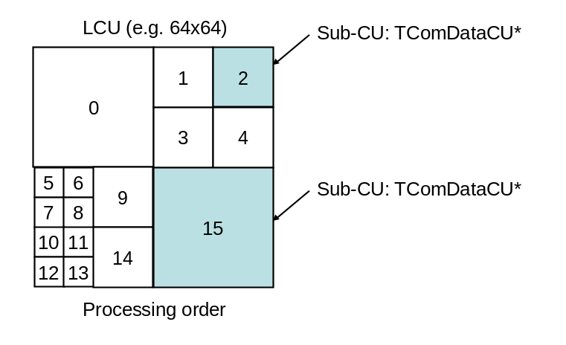Fig. 1: Division into smaller and smaller squares (taken from the HM documentation)
The core of modern video compression, like H.265, is the algorithm that works by first dividing each frame into four equal squares, then recursively it splits each square into four smaller squares as long as certain conditions are met. This data structure is called a quadtree.
Areas with sparse movement – where the absolute value of the residual between images p and p±1, p±2, etc. is small – are not subdivided as much, and these tend to form larger continuous sheets, which can be effectively compressed together. Areas with large residuals for temporally close images need to be subdivided further until smaller, more local redundancies within the images are found, or until the algorithm reaches the individual pixels and no division is possible. These bigger och smaller areas are the basis for the compression, and the smaller ones will demand more from the compression methods.

Methodology
We will measure image quality partly with mathematical metrics (like Peak signal-to-noise ratio), but primarily using the human eye. This is done either by ourselves by comparing different compression settings, or with a group of test subjects in a ”blind study”.
I will also work with an open-source software written in C++ that I will try to improve on. As part of my research I will take a compression course at KTH containing 3 project assignments which I think will improve both my technical skills and also give me experience within the area.

Research on the Area
I am basing the thesis on the IEEE article "Overview of the High Efficiency Video Coding (HEVC) Standard" by Sullivan et al, introductory videos and historical background from Vcodex as well as on the documentation for the HEVC Test Model software – also known as HM.
I will seach for relevant litterature on those aspects of H.265 that I feel are the most interesting and the best candidates improvements.

Miscellaneous
The thesis project will be carried out at Ericsson Research in Kista. I will live in Stockholm during the project, and I expect Ericsson to provide me with a computer and auxiliary equipment needed for the project. I will communicate with Michael Doggett on a weekly basis using email, and video chat if necessary. I expect the weekly summaries that I write to help me greatly with putting together the thesis.
With the project I will contribute to the knowledge on video compression, both through my thesis, but also through the code I write at Ericsson.

Examiner: Jörn Janneck
LTH supervisor: Michael Doggett
Ericsson supervisor: Kenneth Andersson
Dates: 2015-08-24 – 2016-03-01

